

**Faculty of engineering - Shoubra Benha University**

# Research Article / Research Project / Literature Review

in fulfillment of the requirements of

|  |  |
| --- | --- |
| **Department** | **Engineering Mathematics and Physics** |
| **Division** | ----------- |
| **Academic Year** | **2019-2020 Preparatory** |
| **Course name** | **Computer** |
| **Course code** | **ECE001** |

**Title: -**

**Operating Systems**

By:

|  |  |  |  |
| --- | --- | --- | --- |
|  | Name | Edu mail | B.N |
| 1 | رانيا جمال خميس على | rania195373@feng.bu.edu.eg | 340 |

## Approved by:

|  |  |
| --- | --- |
| Examiners committee | Signature |
|  |  |
|  |  |
|  |  |
|  |  |
|  |  |

**Research objectives**

The research objectives are:

* discuss the definition, components, function

And examples of Operating Systems.

* Create website to present Operating Systems

GitHub: <https://github.com/raniagamalkhamis/ECE001-340>

GitHub Pages: <https://raniagamalkhamis.github.io/ECE001-340/>

# Abstract

The operating system is the performance of a computer system hardware abstraction, through which people control the hardware, and to use the resources of the computer system.

The various types of operating systems have made our use of computing devices easier and easier over the recent years.

# Table of contents

Divide your research into sections or subjects, mention each section first page at this table

|  |  |
| --- | --- |
| **Subject / section** | **Page** |
| **Objectives** | **1** |
| **Abstract** | **2** |
| **Introduction** | **4** |
| **Literature Review** | **6** |
| **Results** | **9** |
| **Conclusion** | **10** |

**Introduction**

First, we need to understand what “Operating System” mean.

## Definition:

operating system (OS) is system software that manages computer hardware, software resources, and provides common services for computer programs.

Time-sharing operating systems schedule tasks for efficient use of the system and may also include accounting software for cost allocation of processor time, mass storage, printing, and other resources.

For hardware functions such as input and output and memory allocation, the operating system acts as an intermediary between programs and the computer hardware, although the application code is usually executed directly by the hardware and frequently makes system calls to an OS function or is interrupted by it. Operating systems are found on many devices that contain a computer – from cellular phones and video game consoles to web servers and supercomputers.

## History of Operating Systems:

### Unix

Unix was originally written in assembly language. Ken Thompson wrote B, mainly based on BCPL, based on his experience in the MULTICS project. B was replaced by C, and Unix, rewritten in C, developed into a large, complex family of inter-related operating systems which have been influential in every modern operating system.

### macOS

macOS (formerly "Mac OS X" and later "OS X") is a line of open core graphical operating systems developed, marketed, and sold by Apple Inc., the latest of which is pre-loaded on all currently shipping Macintosh computers. macOS is the successor to the original classic Mac OS, which had been Apple's primary operating system since 1984. Unlike its predecessor, macOS is a UNIX operating system built on technology that had been developed at NeXT through the second half of the 1980s and up until Apple purchased the company in early 1997.

### Linux

The Linux kernel originated in 1991, as a project of Linus Torvalds, while a university student in Finland. He posted information about his project on a newsgroup for computer students and programmers, and received support and assistance from volunteers who succeeded in creating a complete and functional kernel.

### Microsoft Windows

Microsoft Windows is a family of proprietary operating systems designed by Microsoft Corporation and primarily targeted to Intel architecture-based computers, with an estimated 88.9 percent total usage share on Web connected computers. The latest version is Windows 10. In 2011, Windows 7 overtook Windows XP as most common version in use.

# Literature Review

## Components of Operating System

the components of an operating system play a key role to make a variety of computer system parts work together.

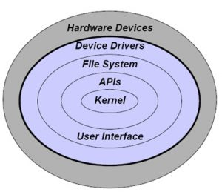

## What each component of Operating System do

|  |  |
| --- | --- |
| **KERNEL** | The kernel gives one of the most fundamental level of control over all the computer’s hardware devices. The kernel is the central component of an operating system (OS). It is the component of the operating system that loads initially, and it lingers in main memory. It manages memory accessibility for programs in the RAM, it establishes which programs get access to which hardware resources. It establishes or resets the CPU’s operating states for optimum operation in all times. |
| **PROCESS EXECUTION** | The operating system offers an interface in between an application program and the hardware, so that an application program can connect with the hardware just by following principles and procedures configured into the operating system. Executing an application program includes the creation of a process by the operating system kernel which appoints memory space and various other resources. |
| **INTERRUPT** | Interrupts are primary to operating systems, as they offer a reliable method for the operating system to interact with and respond to its environment. An interrupt is a signal from a device connected to a computer system or from a program within the computer system that needs the operating system to quit and determine exactly what to do next. When an interrupt is received, the computer’s hardware automatically puts on hold whatever program is presently running, saves its status, and runs computer system code formerly associated with the interrupt. |
| **MEMORY MANAGEMENT** | This makes sure that a program does not conflict with memory currently being used by an additional program. Since programs time share, each program has to have independent access to memory. To puts it simply, the MMU is in charge of all aspects of memory management. It is normally integrated right into the cpu, although in some systems it takes up a separate IC (integrated circuit) chip. |
| **MULTITASKING** | Multitasking describes the operating of multiple independent computer programs on the same computer system. The operating system has the ability to keep an eye on where you are in these jobs and go from one to the various other without losing information. Since a lot of computers can do at most one or two things at once, this is usually done using time-sharing, which means that each program utilizes a share of the computer’s time to perform. |
| **NETWORKING** | The processors interact with each other via communication lines called network. The communication-network design should consider routing and connection techniques, and the troubles of opinion and safety and security. Presently most operating systems sustain a range of networking methods, hardware, and applications for using them. This implies that computers running different operating systems could take part in a common network for sharing resources such as computing, data, printers, and scanners making use of either wired or wireless connections. |
| **SECURITY** | If a computer system has several individuals and enables the simultaneous operation of multiple processes, then the numerous processes have to be secured from each other’s activities. A computer system being safe and secure depends upon a variety of technologies working effectively. A modern-day operating system offers access to a number of resources, which are readily available to software working on the system, and to external devices like networks by means of the kernel. |
| **USER INTERFACE** | It is everything created into an information device with which an individual might interact. The user interface is generally described as a shell and is vital if human communication is to be supported. The user interface checks out the directory framework and requests services from the operating system that will obtain information from input hardware devices and demands operating system services to display prompts, status messages and such on output hardware devices. |

# Results and discussion

**The Website of Operating Systems:**

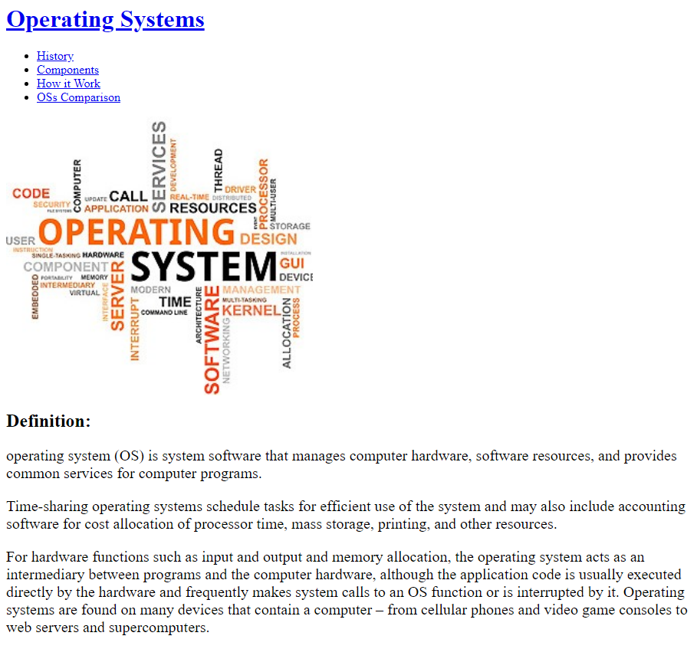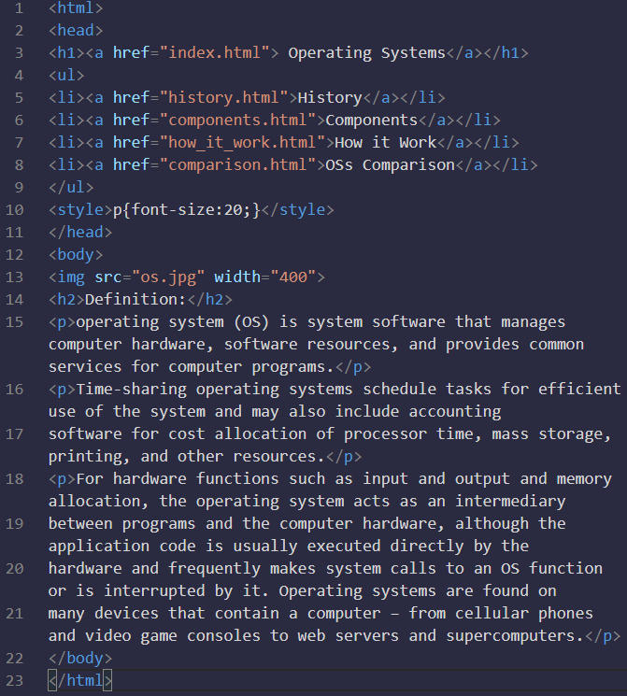

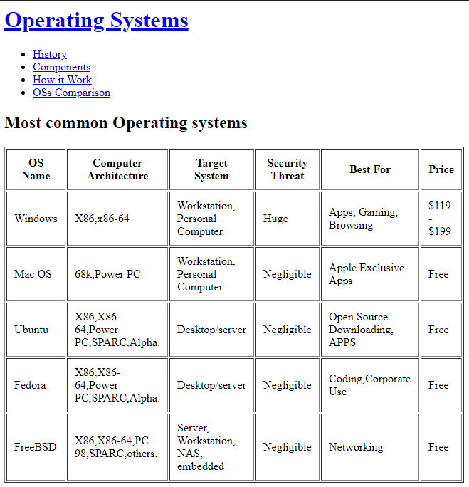 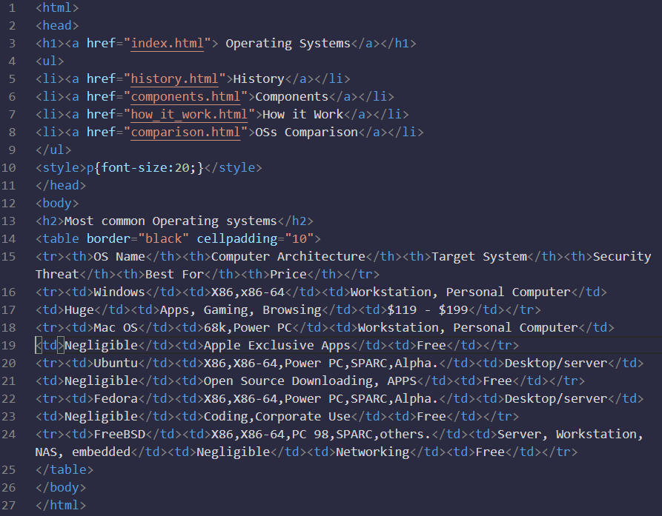

# Conclusions

Very important! In conclusion, an operating system is a software that manages computer hardware and software resources, and to provide public services for computer programs. The operating system is an important part of the system software in a computer system.

# References

Includes a list of references that helped you in your research

### the Egyptian Knowledge Bank, EKB.

### https://www.ukessays.com/